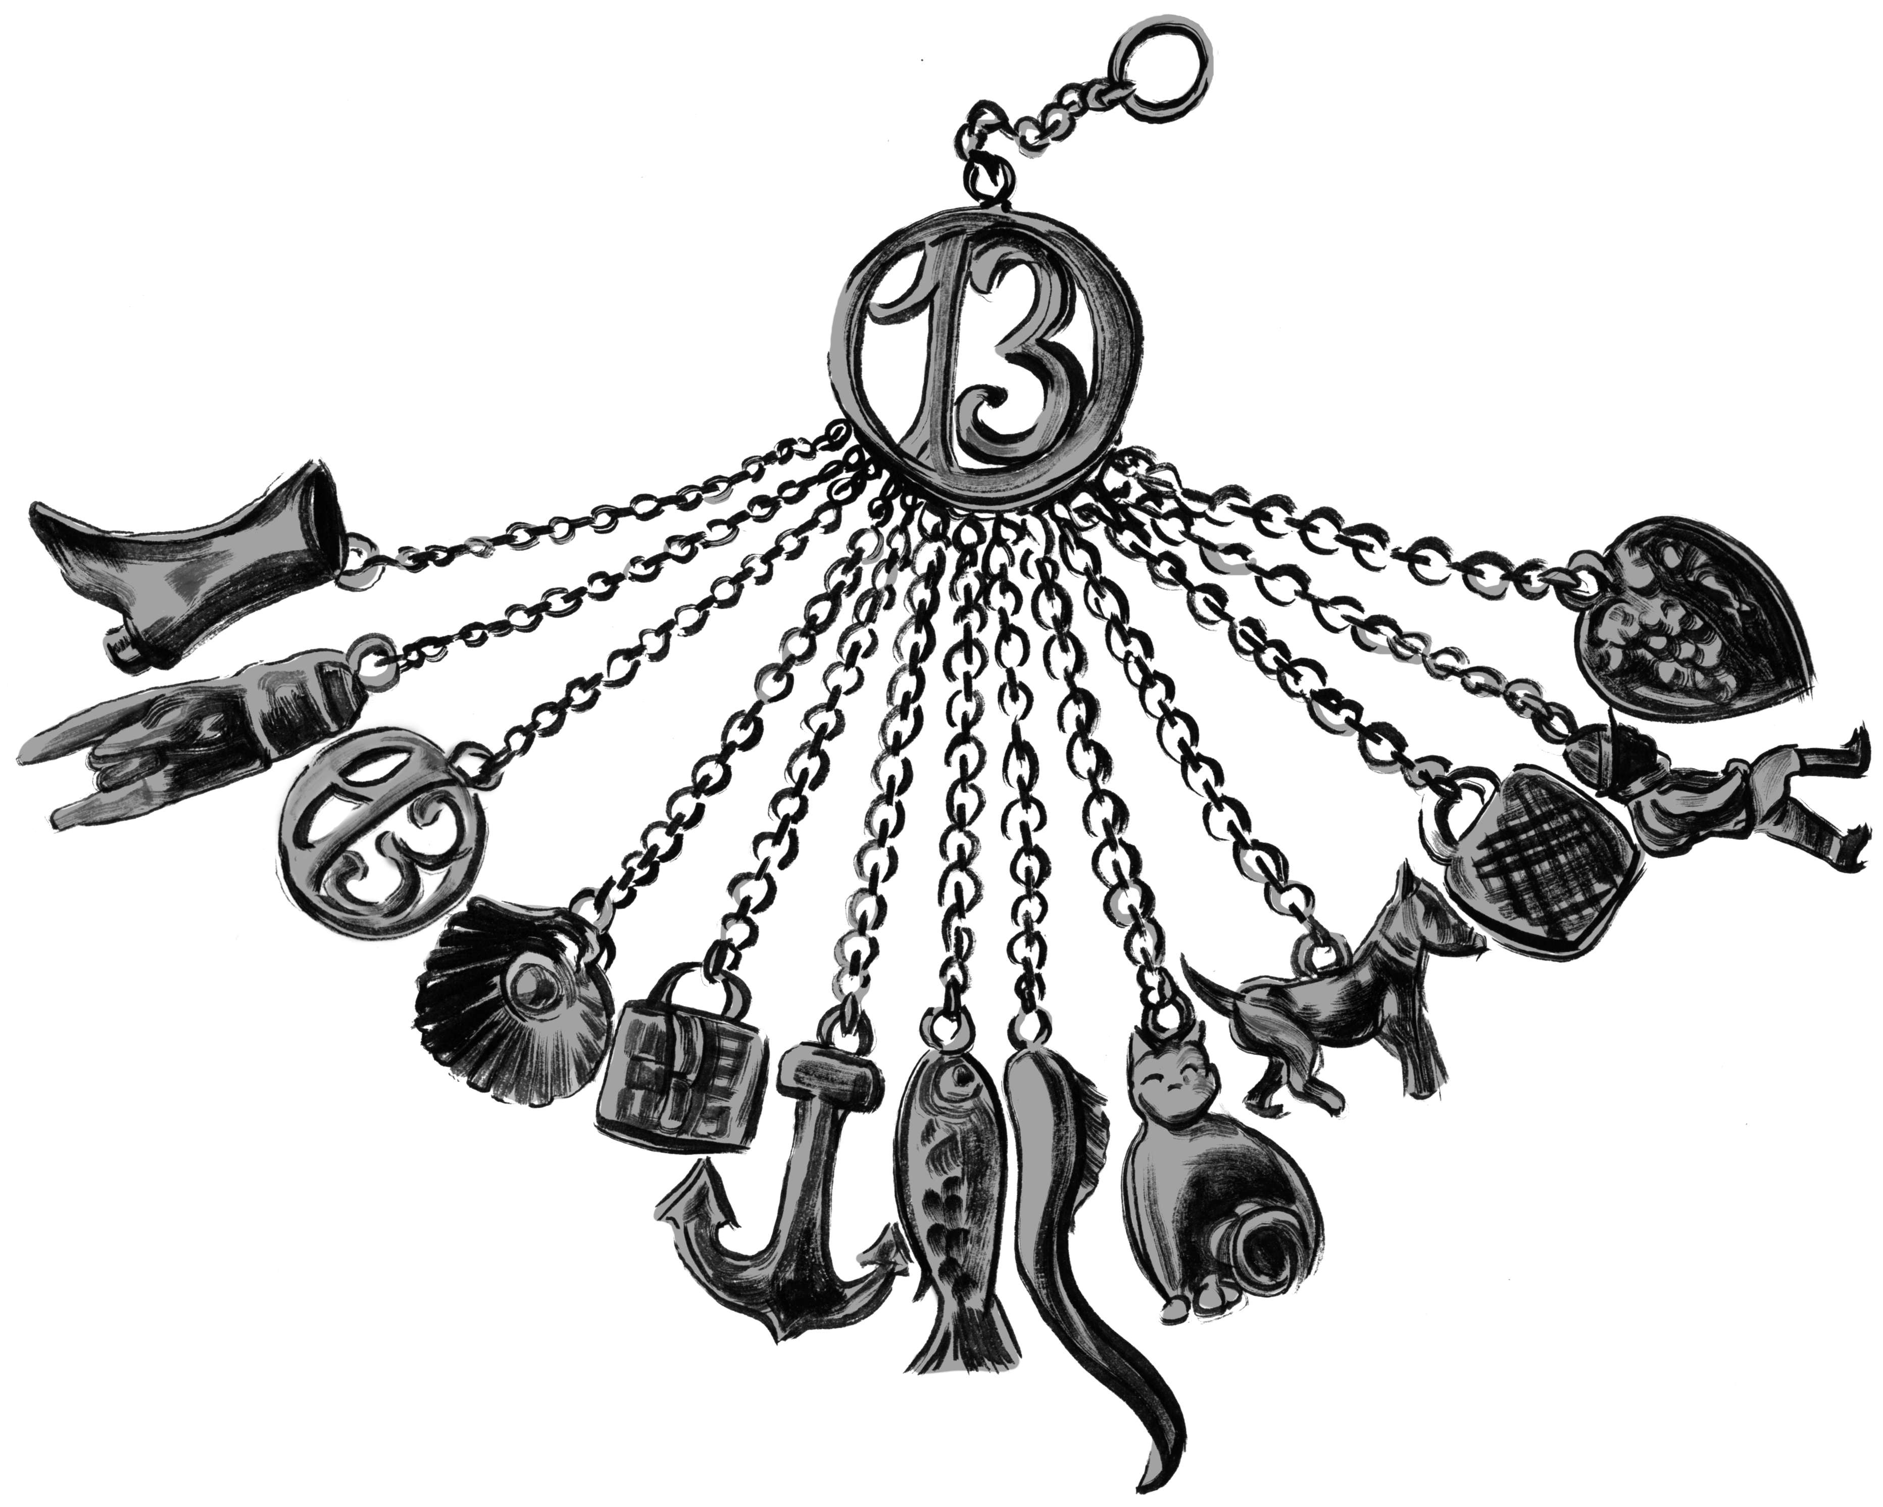

How he wishes he could have saved the others before him—the fishmonger’s daughter, the hunchback boy, the singing girls—but he is only a boy, brave but not brave enough, more mouse than cat, and at the mercy of a monster too dreadful to behold.

No, he is not the first to be taken. Nor will he be the last.

One of John’s own cats, fresh from the night’s kill, betrays him, cat-boy John. Poor lovey kitten drops a mouse on John’s bare right toe before she speeds away to escape the monster. The last John hears is a string of accursed words in a voice that comes from the depths, perhaps from the devil himself…by blood and bone…
—The Charmed Children of Rookskill Castle

Seek the Pen to save this charmed child, John.

Clue 1: Look for the Pen in a book filled with cats penned by …Programmer adds additional clues here.

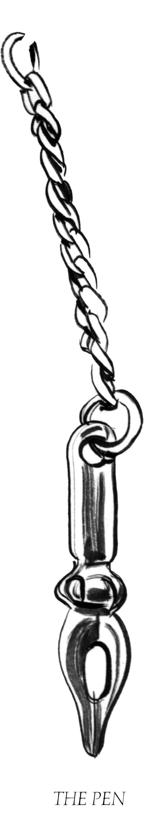
Someone was huddled on the floor by the stove, and Kat could see feet. Small feet. Someone young.

A cat trotted across the kitchen, and then another. The cats wrapped themselves around the feet, twining and mewing, until one dropped to a hunch on the floor by the feet and began to groom…

…Kat startled the living daylights out of the boy, handsome and dark-haired though thin, wraith-thin, huddled by the stove. Kat startled him so that he sprang up, his dark eyes blank and staring, ghostly, and he bolted out the back door into the miserable weather, cats on his heels, slamming the door in his wake.

—The Charmed Children of Rookskill Castle

Seek the Thimble to save this charmed child, John.

Is John a ghost or something quite different?

Clue 2: Look for the Thimble amongst the ghost stories.
Programmer adds additional clues here.

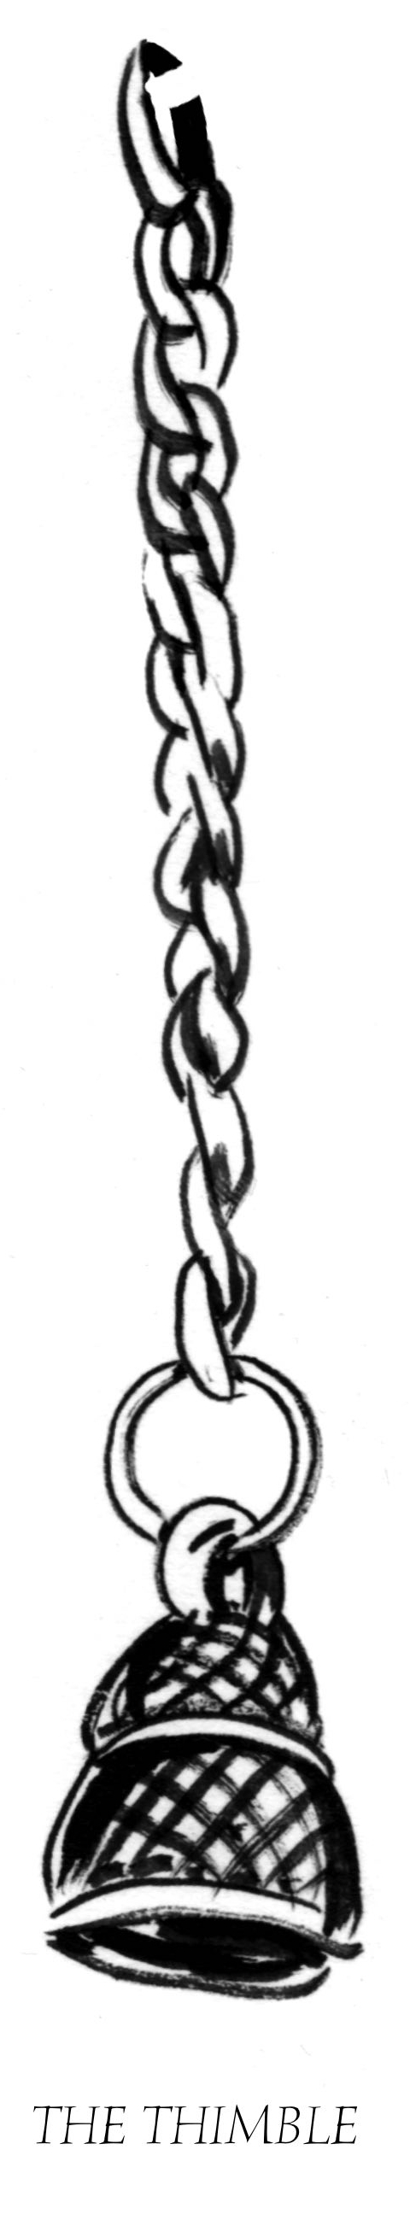
Great-Aunt Margaret replaced the scissors and lifted the third item, also hooked to its slender chain.

“Ah.” She sighed. “The thimble. You know what that means.”

Finally, Kat allowed herself a smile. “A kiss,” she answered. Aunt Margaret had read Peter Pan to
them so often that the cover was coming apart from the binding; Robbie played at being one of the Lost
Boys, especially since taking up fencing….

“Well, yes,” Great-Aunt Margaret said, seeming disconcerted. “That, of course. Thimbles also have
often been given as wedding gifts and love tokens. But this thimble has a magical aspect. This thimble
can catch souls.”

—The Charmed Children of Rookskill Castle

Seek two pairs of Scissors to save this charmed child, John.

John was a boy in the year 1863. He is still a boy in 1940. Is he a lost boy like Peter Pan, forever young?

Clue 3: Look for the Scissors in the story of the lost boys.

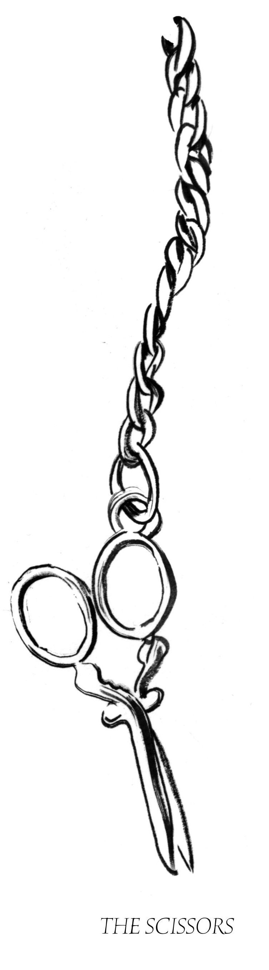
[The magister’s] fingers are skilled at making. He can make mechanicals, unearthly creatures that are beautiful but dreadful. He adds the still-beating heart of a once-living thing to a clockwork creation that blinks and moves…

He ponders the capture of souls…The magister does not tell Leonore what he does…

The twin girls, together with Rose and Tim, for the next century and more, haunt the castle and the grounds and sing wordless songs. Leonore swells with the power she sucks from the souls of the four children. She later adds the fifth, the lonely cat-boy John, telling herself that this is good, this is right, this taking of children’s souls.
—The Charmed Children
of Rookskill Castle

Seek a Broken Heart to save John and the other charmed children.

Clue 4: Look for the Broken Heart in a Caldecott Medal-winning book about a boy named Hugo who lived amongst clockwork.

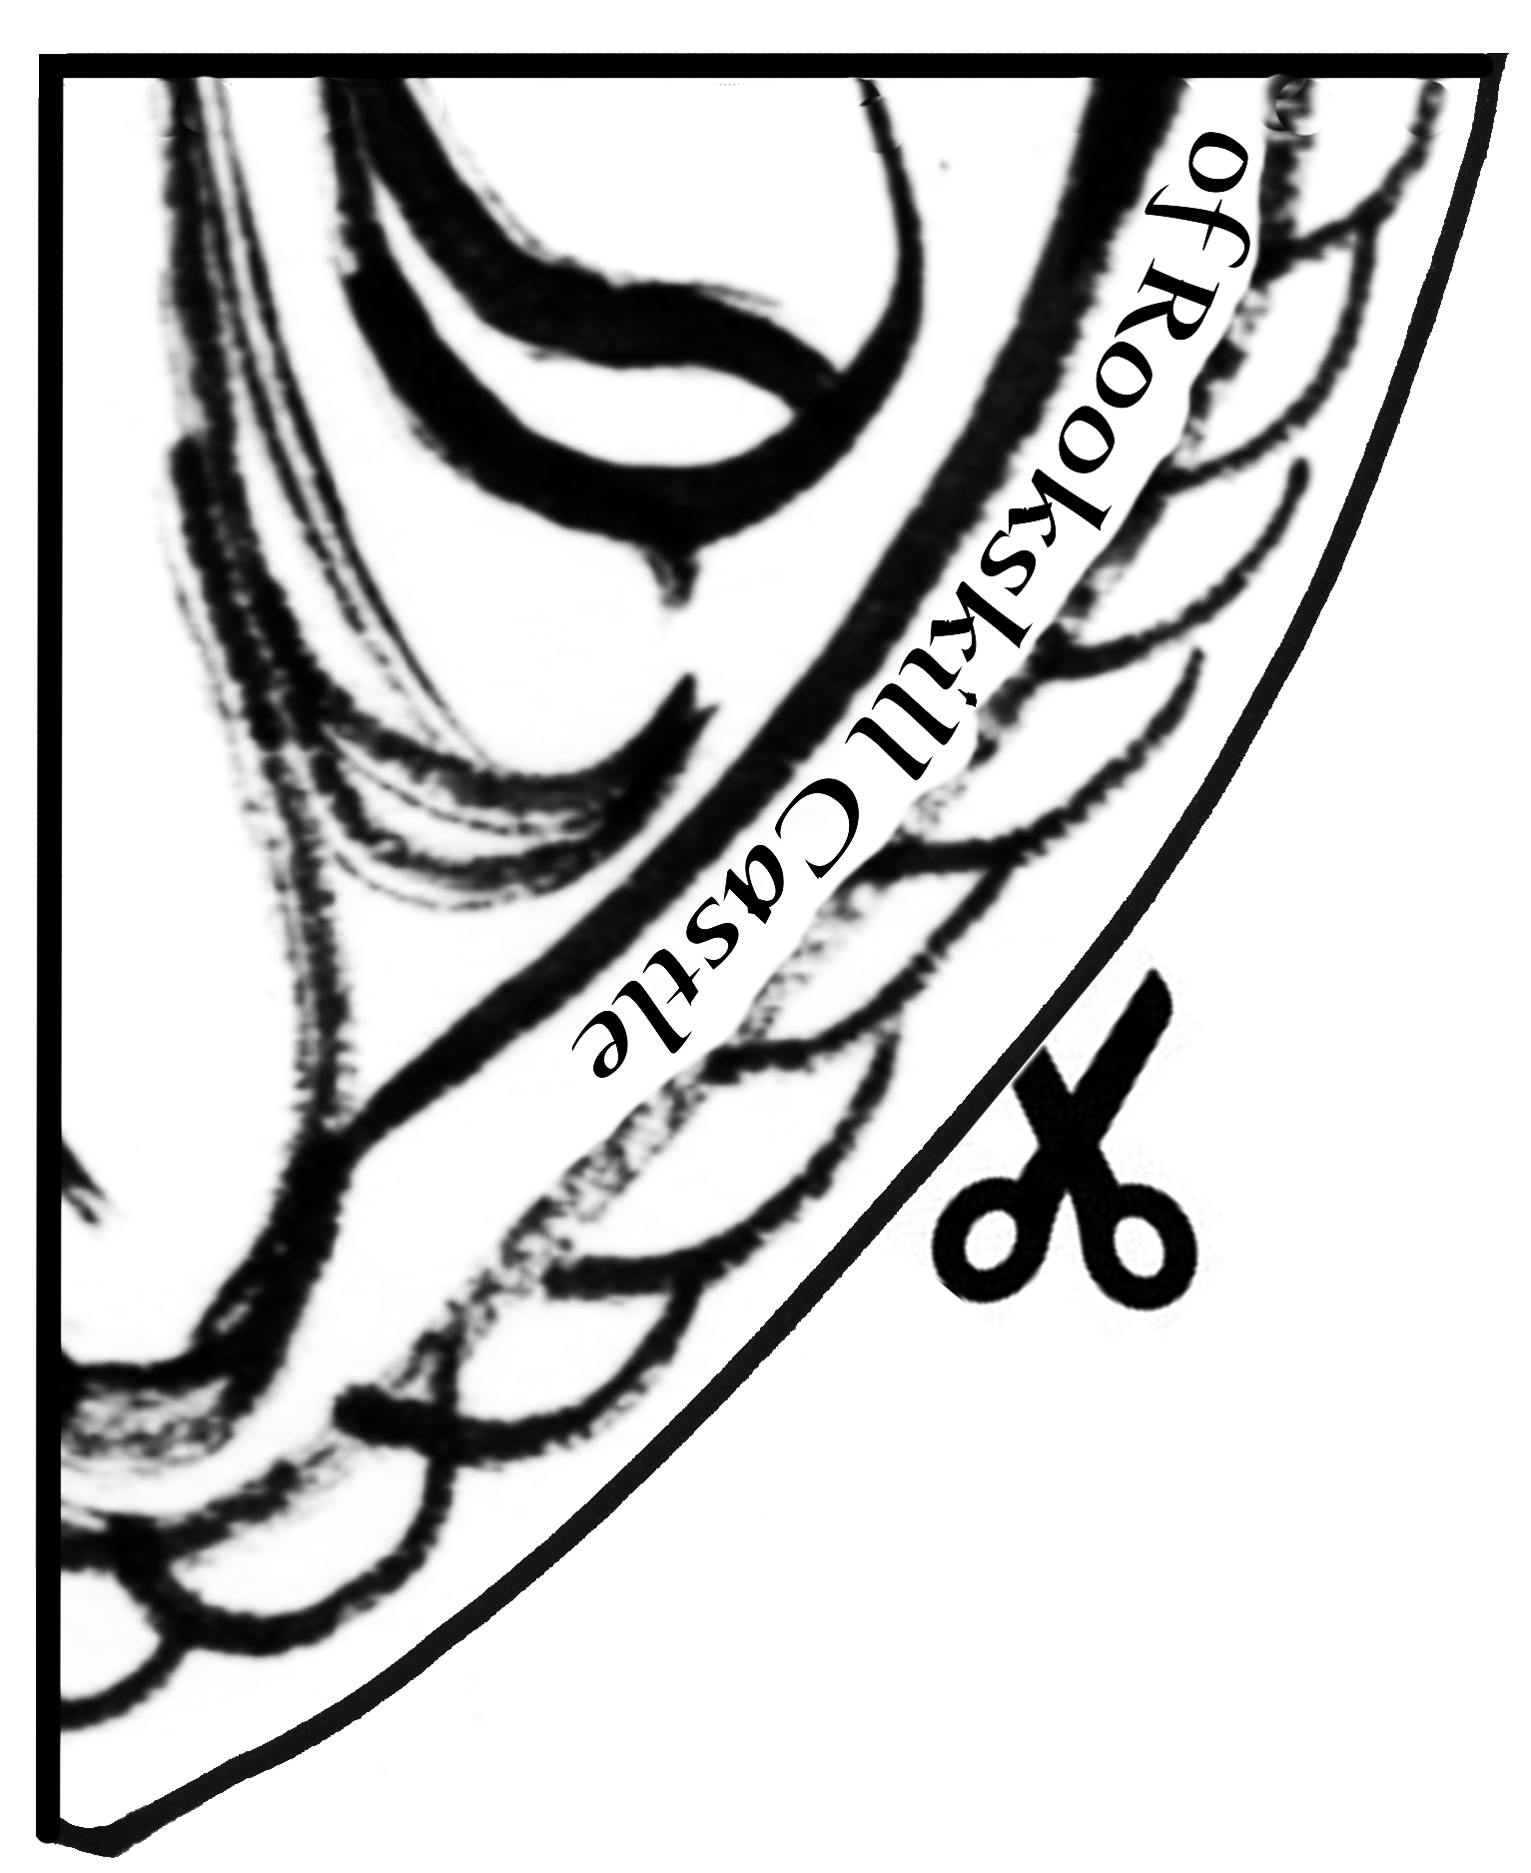

“But we’ve got no time now, Cook, for anything but the other children,” Kat said. “We’ve stopped her for now, but I fear she’ll make an escape, and then be after us all. Please help us convince Hugo to let us see the others.”

—The Charmed Children of Rookskill Castle

Clue 5: Seek the Other Children who wear the symbol of the fish, the boot, and the hunchback. Together you will solve the mystery of this Broken Heart and perhaps rescue the Charmed Children of Rookskill Castle.

