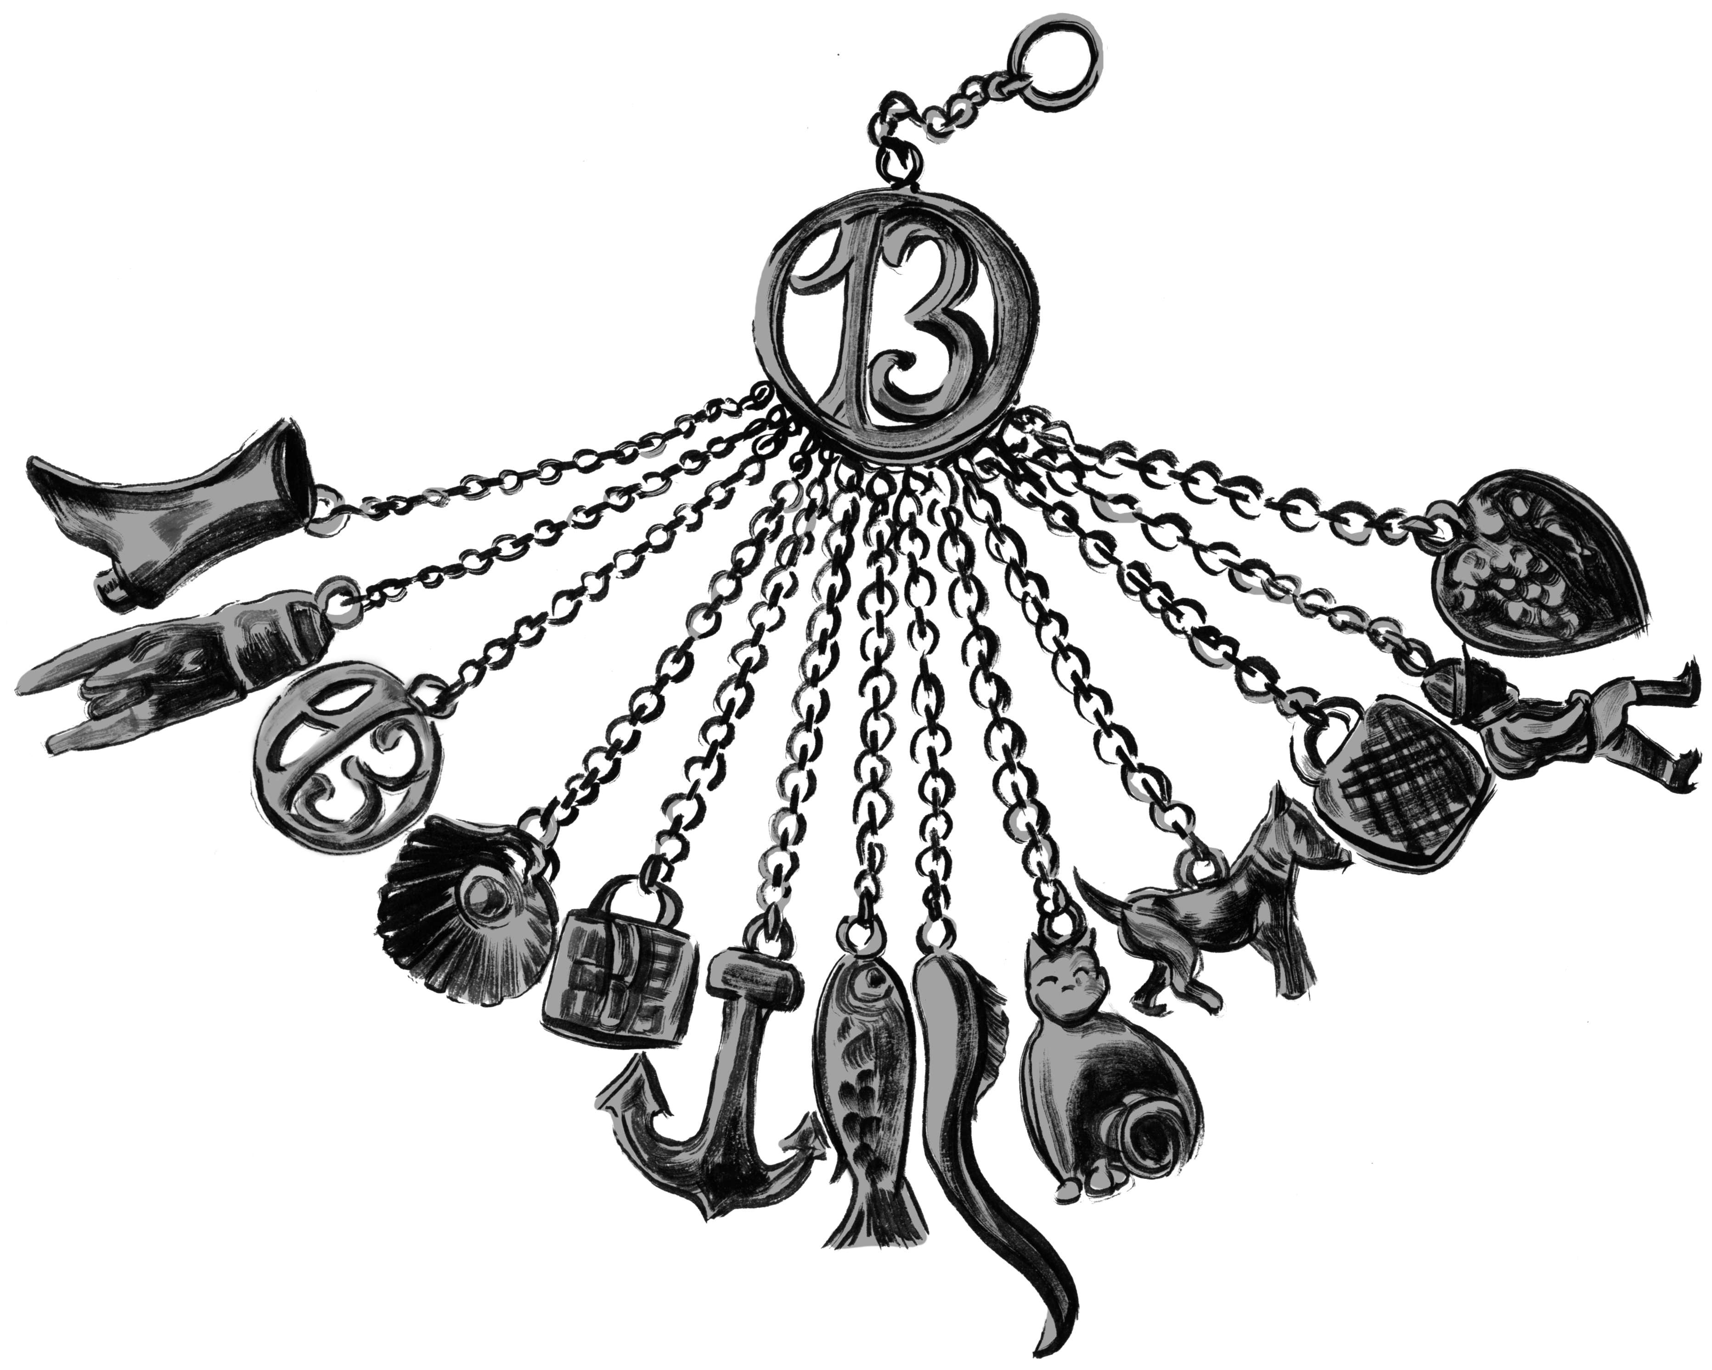

The beautiful lady takes his hand and folds his fingers around the chain.
A braided circle of white hair crowns her black hair like a halo. The silver charm hangs from the chain in his hand. As if it has been made for him.
In the shape of this charm, his deformity is beautiful.
—The Charmed Children of Rookskill Castle

Seek the Pen to save this charmed child, Tim.

Clue 1: Look for the Pen in a novel penned by Victor Hugo.

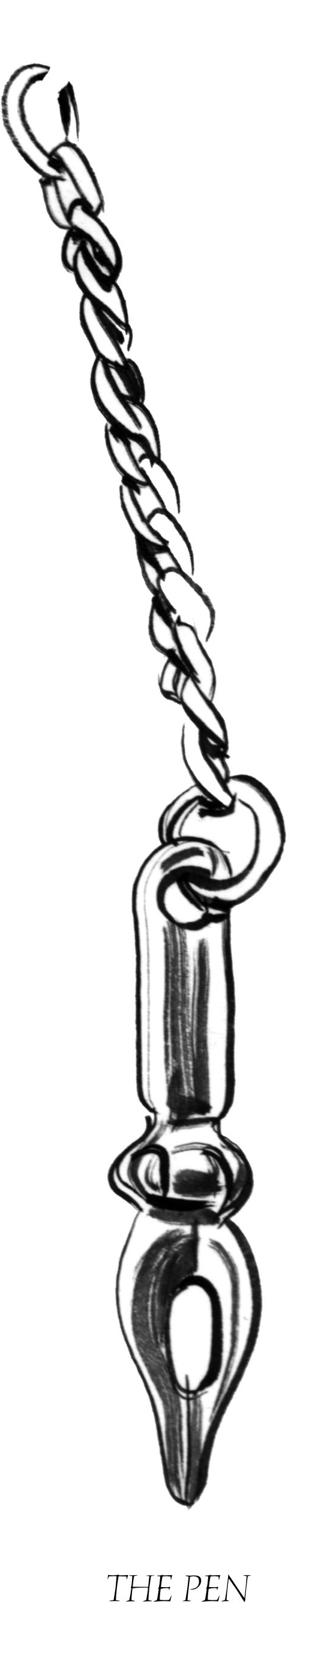
Tim is in his private place, the place he’s found at the bottom of the bottom, the place where he lies neither dead nor alive next to the furnace on a bed of straw…

Arrayed around him now are the lovely, shiny baubles he has collected over centuries in this drafty castle, candlesticks and bowls, platters and forks. He breathes a sigh and takes his polishing rag and goes to work…
—The Charmed Children of Rookskill Castle

Seek the Thimble to save this charmed child.
For 200 years, this charmed child has been drawn to the glint of silver.

Clue 2: Look for the Thimble in Narnia.

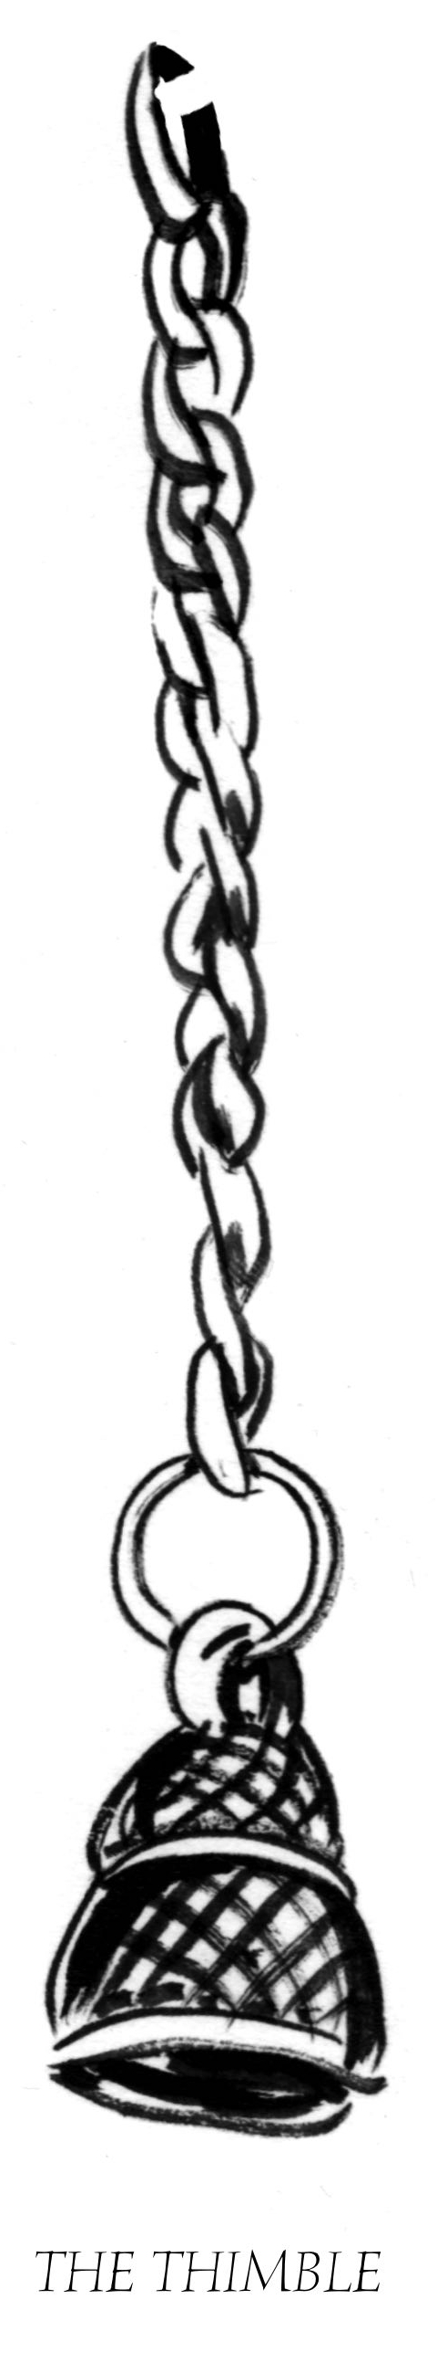
The dining hall—for it was a great hall—was paneled in dark wood and watched over by rows on either side of metal-armored men, each holding a different weapon…

Amelie tugged at Kat’s sleeve and Kat bent down.

“They’re worried,” Ame said.

“Who are?”

“The men,” she said. She paused before one of the suits of armor and lifted her small finger to touch the glove with its rows of knuckle spikes.

“Ame, there are no men,” Kat said. “These are empty suits of armor. How can they be worried?” A little shiver wove across her shoulders.

—The Charmed Children of Rookskill Castle

Seek two pairs of Scissors to save Tim and these other children in danger of being charmed.

Clue 3: Look for the Scissors in suits of armor. Programmer adds additional clues here.

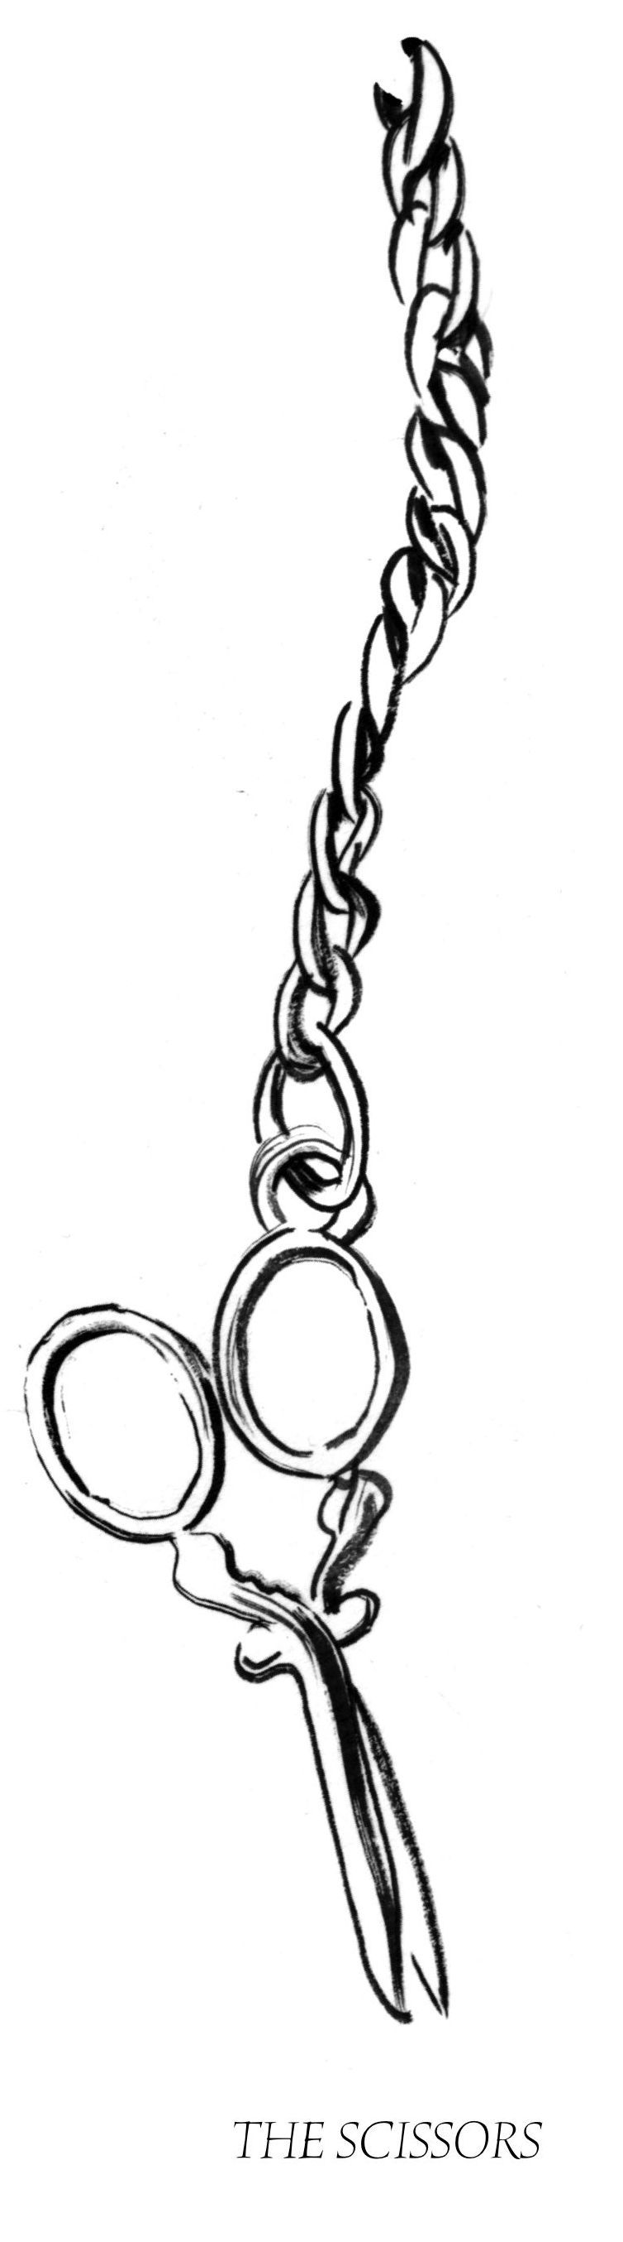
Peter and Rob still had their swords. The two boys with their weapons and grim faces looked more and more like they belonged in this old place. Rob got his wish, Kat thought. They are knights in training. She couldn’t help noticing how much older both Rob and Peter looked.
—The Charmed Children
of Rookskill Castle

Seek a Broken Heart to save Tim and these other children in danger of being charmed.

Clue 4: Look for the Broken Heart in tales of brave knights. Programmer adds additional clues here.

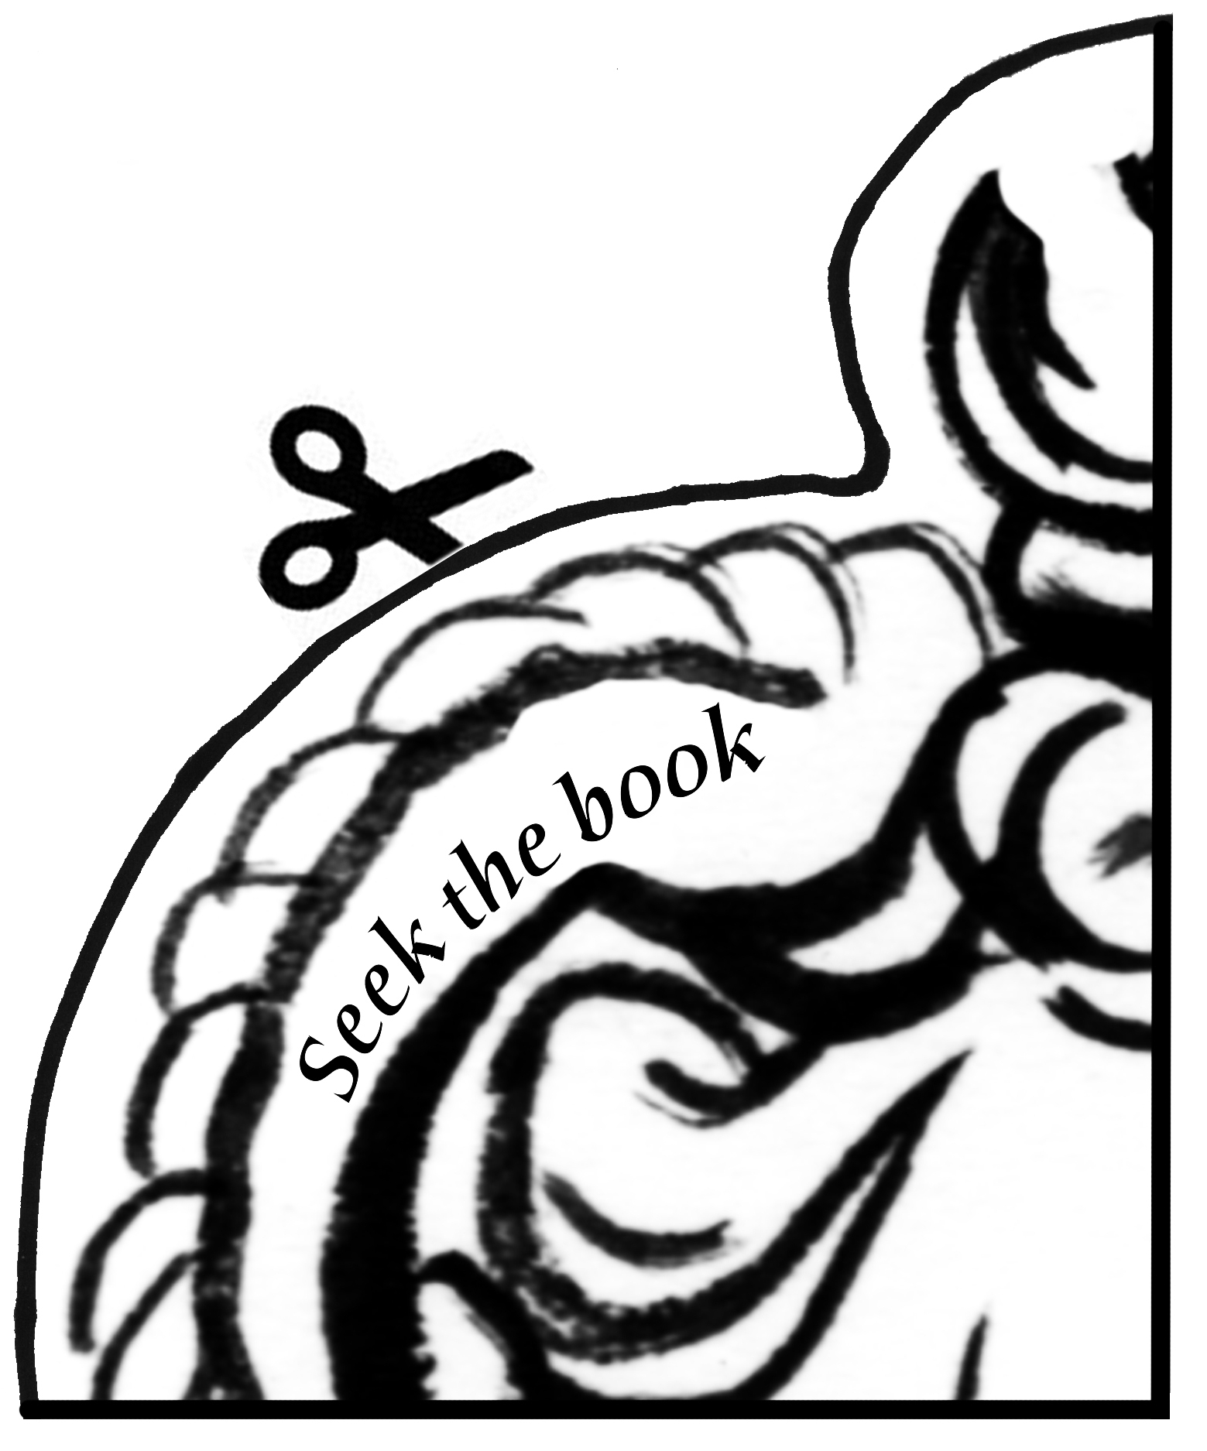

“But we’ve got no time now, Cook, for anything but the other children,” Kat said. “We’ve stopped her for now, but I fear she’ll make an escape, and then be after us all. Please help us convince Hugo to let us see the others.”

—The Charmed Children of Rookskill Castle

Clue 5: Seek the Other Children who wear the symbol of the fish, the boot, and the cat. Together you will solve the mystery of this Broken Heart and perhaps rescue the Charmed Children of Rookskill Castle.

