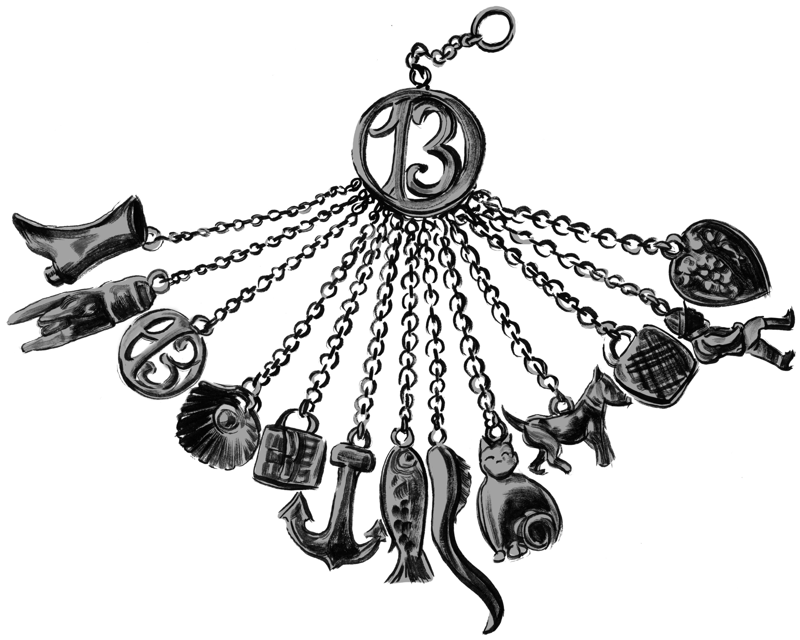

They cling to each other, Alice carrying a single boot and Brigit clutching a small locked chest. The twins wander to the cliff edge. Leonore follows them and gives them each a charm from her chatelaine, the boot and the chest.

As the years pass, the villagers think the caves along the coast house mermaids. They hear sweet, sad voices that lift and swell and ebb like waves. They leave the caves alone, not wishing to disturb the sorrowful selkies. But the voices belong to girls charmed by Leonore.
—The Charmed Children of Rookskill Castle

Seek the Pen to save the charmed children, Alice and Brigit.

Clue 1: Look for the Pen in a tale of a mermaid who desires to walk on land. Will she wear boots like the one Alice carries? The author, Hans Christian Andersen, never told us.

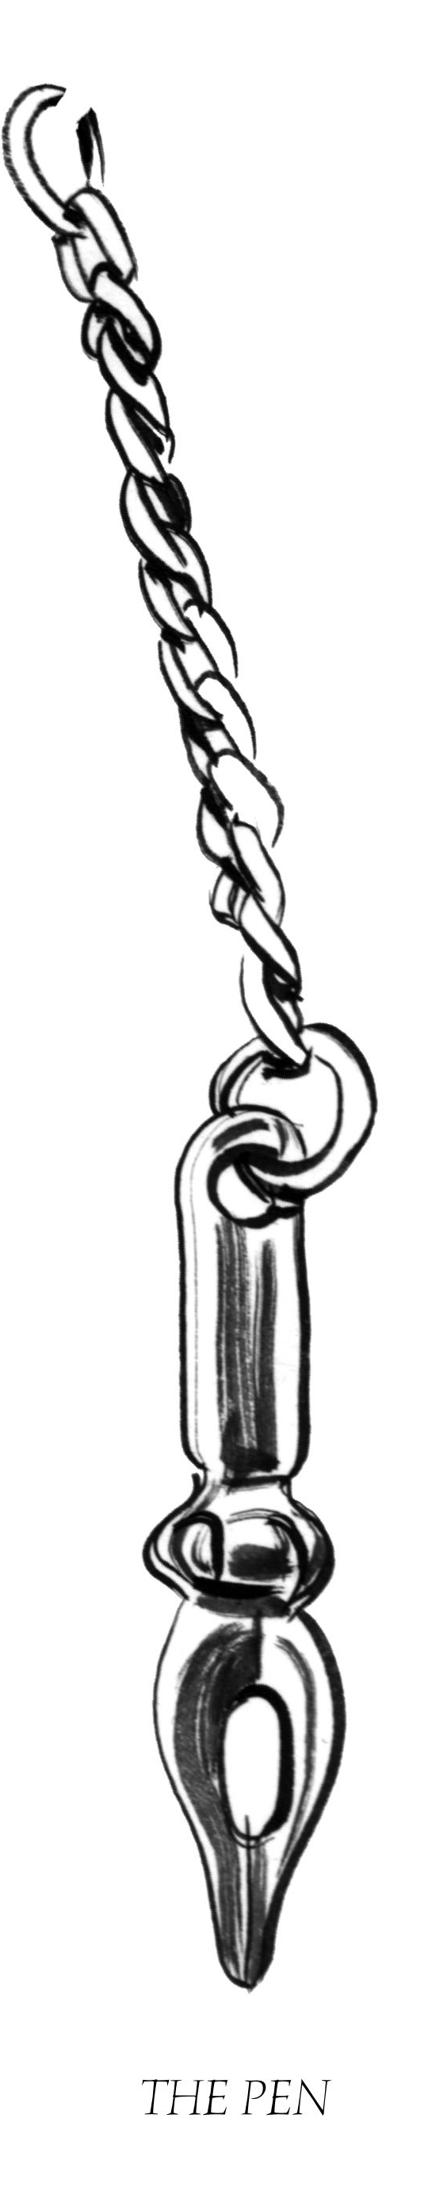
The twin girls, Alice and Brigit, with their wordless tunes, find their way to the top of the high tower, the keep, from which they can see the wide gray ocean, and they sing to the water, Alice still clutching her one old boot and Brigit still clasping her locked treasure chest, and the things that mimic their relics are charms that hang round their necks on thin silver chains.

Alice and Brigit sing to the sea, sing for the loss of their parents and home, and their voices carry down the allée of trees to the ocean’s edge, carry over the water and back, some trick of the land and seascape that brings their voices back like a bird returning to roost.

The villagers, hearing the sad melodies as if they come from the ocean itself, believe in selkies, selkies with the voices of angels.

—The Charmed Children of Rookskill Castle

Seek the Thimble to save the charmed children, Alice & Brigit.

Clue 2: Find the Thimble in tales of the half-human selkies.
Programmer adds additional clues here.

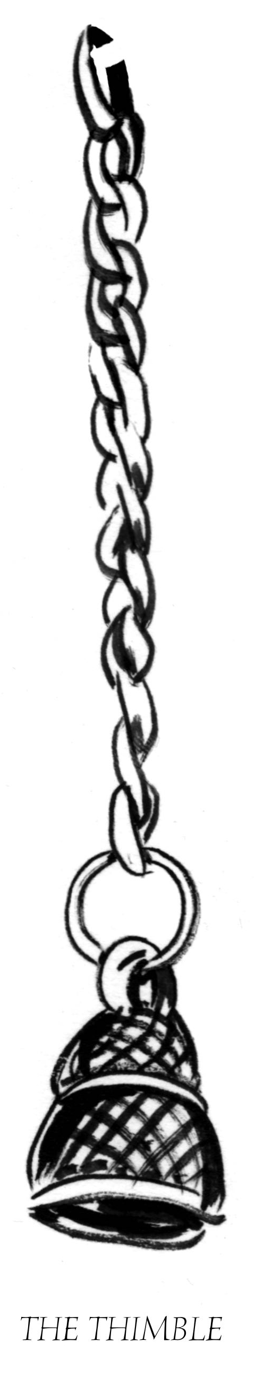
“What is that?” said Colin.

“It sounds like singing,” Kat said. “Like it’s coming from the sea.”

They walked, quickly now, all the way down the allée to the cliff edge, where the land fell into the
rocks and surf, but there was nothing, just the crashing of waves, and over them barely, a sound like
voices, a wordless song in harmony.

“I’ll bet it’s some hollow in the rocks where the wind is whistling through,” said Peter.

“But what if it is ghosts?” asked Colin. “The villagers think the Lady Leonore haunts the castle.”

Kat put her hand on Colin’s thin shoulder. “There are no such things as ghosts,” she said as firmly
as she could. “So you needn’t worry.”

—The Charmed Children of Rookskill Castle

Seek two pairs of Scissors to save Alice, Brigit, and these other children in danger of being charmed.

There once was a sailor called Odysseus who was haunted by the songs of women in the sea.

Clue 3: Look for the Scissors in one of the oldest surviving stories.

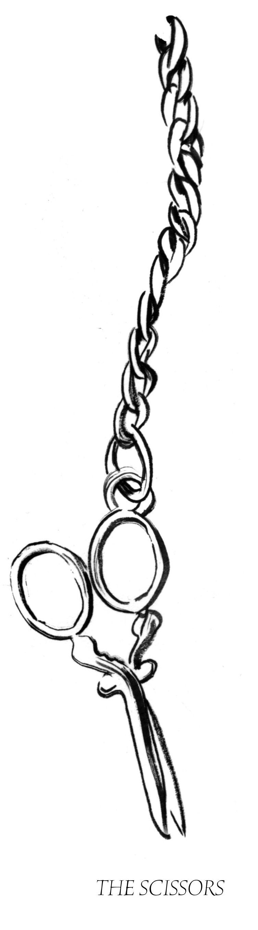
The windows were like stretched-thin black eyes, and the castle was three stories tall with tight brickwork. A dead vine wound around the door frame like a thick rope and the whole was topped by a peaked slate roof poked through with narrow chimneys.

A freshly hand-painted wooden sign was mounted on posts beside the entry: ROOKSKILL CASTLE CHILDREN’S ACADEMY.

Gooseflesh crept up Kat’s arms. She’d tumbled headlong into a fairy tale, like Alice down the
rabbit hole.
—The Charmed Children
of Rookskill Castle

Seek a Broken Heart to save Alice, Brigit, and these other children in danger of being charmed.

Clue 4: Look for the Broken Heart in a classic wonderland of a story about a girl named Alice.

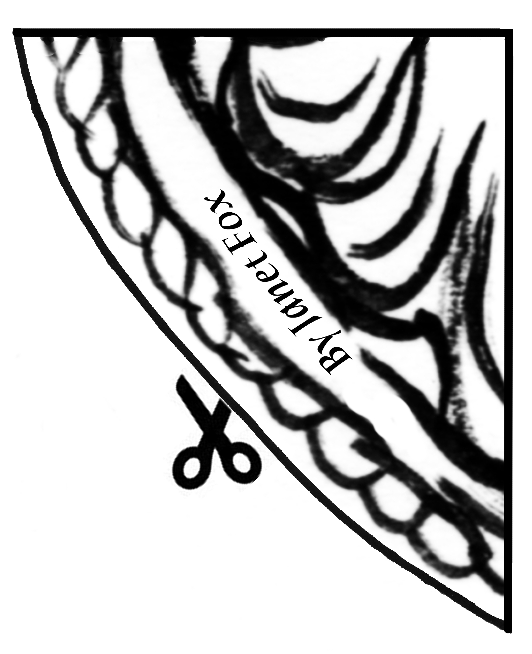

“But we’ve got no time now, Cook, for anything but the other children,” Kat said. “We’ve stopped her for now, but I fear she’ll make an escape, and then be after us all. Please help us convince Hugo to let us see the others.”

—The Charmed Children of Rookskill Castle

Clue 5: Seek the Other Children who wear the symbol of the fish, the hunchback, and the cat. Together you will solve the mystery of this Broken Heart and perhaps rescue the Charmed Children of Rookskill Castle.

