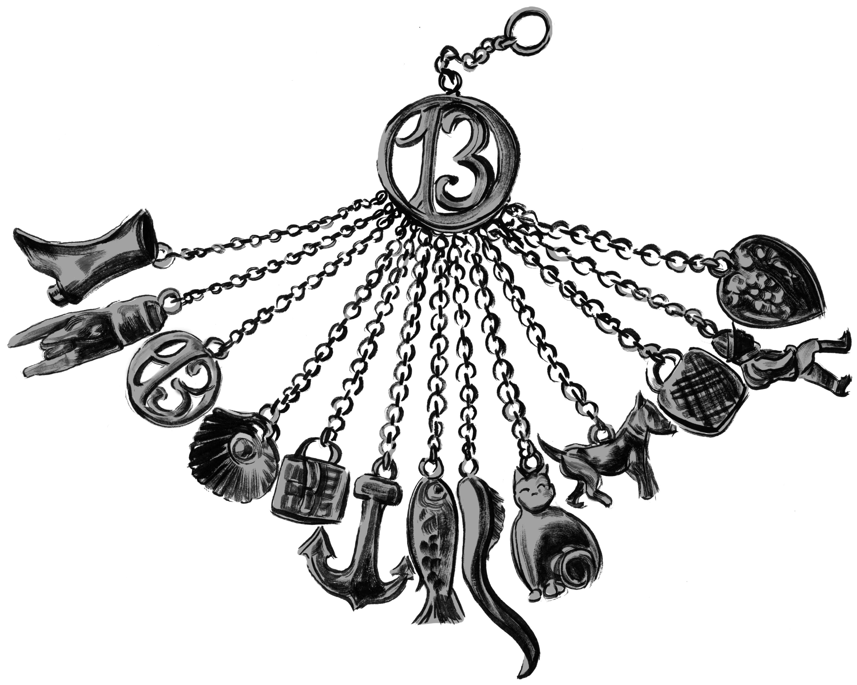
…as Rose hangs the charm around her neck and Leonore repeats the whispered words from the magister, the child cries out, then slips into a vacant-eyed silence…the charmed child Rose walks behind her like a silent shadow, frail as a wisp. But Leonore is stronger than she was before she cast the spell…Instead of feeling lighter for the loss of the little fish charm, Leonore’s chatelaine feels a wee bit heavier.
—The Charmed Children of Rookskill Castle

Seek the Pen to save the charmed child, Rose.

Clue 1: Look for the Pen in a book brimming with fish. Programmer adds additional clues here.

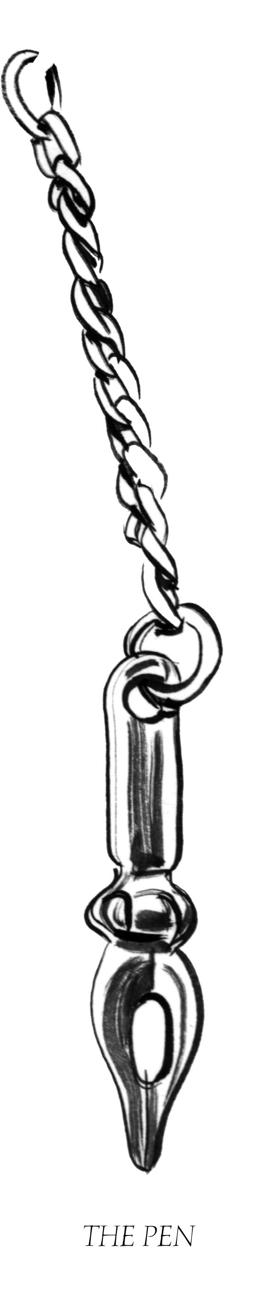
The charmed child Rose, who wears the small silver fish, has feelings, yes, but they’re locked deep inside. And she has memories, too, of a small cottage with a mum who held her, and of the many sisters who scrabbled around fighting and bossing and laughing, but her memories are ghosts, wispy things.

Rose tries to catch her memories. The little pond in the garden is where she goes with a net she’s
fashioned from a tangle of wires and strings and strands of her long yellow hair. She sits at the edge of the pond and waits for a fish. A memory fish.

She is very patient, that Rose.
—The Charmed Children of Rookskill Castle
Seek the Thimble to save this charmed child, Rose.

Rose uses a tangle of wires to fish, but you will need to find out what a “wireless” is to help her.
Clue 2: Look for the Thimble Programmer adds additional clues here.

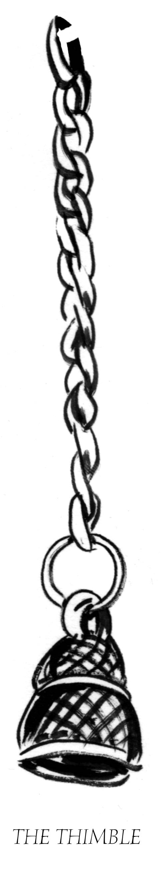
To their left stood a half-ruined square keep topped by battlements; to their right, a high wall with turrets. The keep’s narrow windows slotted the wall like blank eyes, and Kat imagined someone aiming an arrow from one straight at her heart. The moat bed was a rocky trough of thorny weeds.

As they crossed the bridge Kat shut her eyes at the bony rattles made by the wood straining beneath their weight, then opened them as they passed beneath the gate arch, its rotting gate hovering overhead.

—The Charmed Children of Rookskill Castle

Seek two pairs of Scissors to save Rose and these other children in danger of being charmed.

Clue 3: Look for the Scissors in a book with a castle moat in its pages. Programmer adds additional clues here.

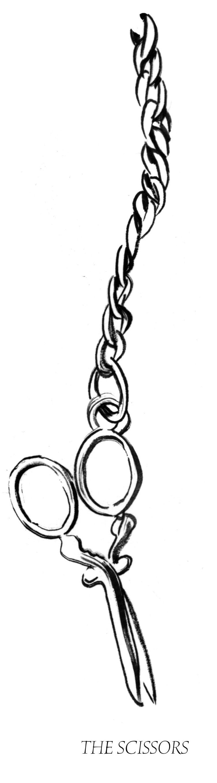
The woods, the rough coast, the moors beyond were treacherous and would be an easy place in which to be lost, especially in fog. There was no need of a castle moat, no need for shuttered gates. They were all here until the bitter end, and Kat swallowed the lump in her throat. She touched the cold glass with her fingers before she turned away.

But Amelie tugged at her sleeve. “No. Look.” Ame pointed down into the near garden. Kat leaned
against the glass to see.

Straight below them a small girl with blonde hair sat on the stone edging of an empty round fishpond. How Kat hadn’t seen her right off was a mystery…As Kat watched, the girl reached into the rocks and lifted something out, and for an instant there was a flash of silver in the child’s hand. Kat blinked and rubbed her eyes.

—The Charmed Children of Rookskill Castle

Seek a Broken Heart to save Rose and these other children in danger of being charmed.

These children could be lost on the moors.

Clue 4: Look for the Broken Heart in a book about a girl named Jane Eyre who was once lost on the moors.

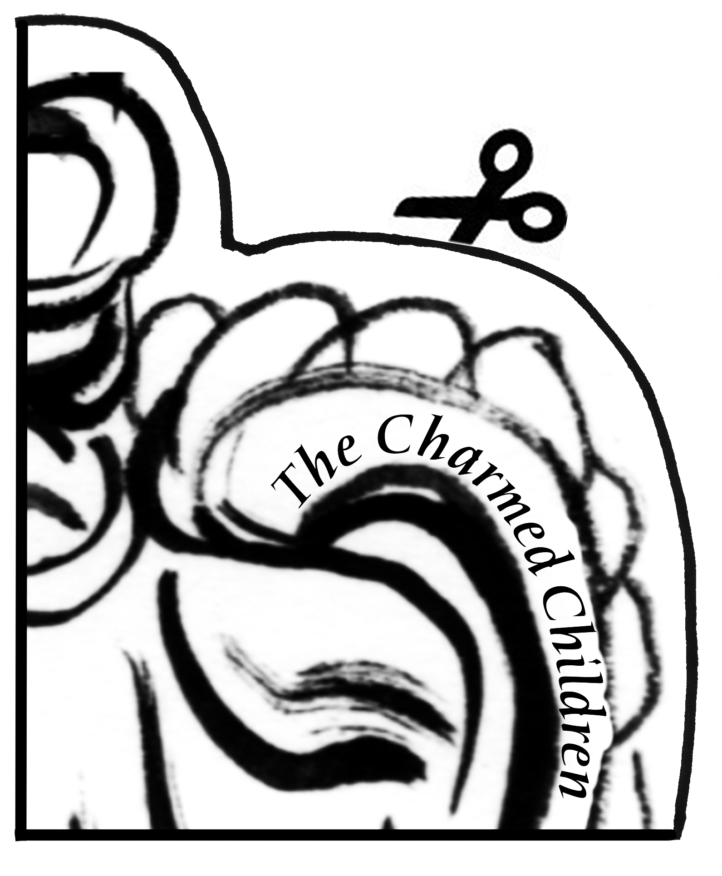

“But we’ve got no time now, Cook, for anything but the other children,” Kat said. “We’ve stopped her for now, but I fear she’ll make an escape, and then be after us all. Please help us convince Hugo to let us see the others.

—The Charmed Children of Rookskill Castle

Clue 5: Seek the Other Children who wear the symbol of the hunchback, the boot, and the cat. Together you will solve the mystery of this Broken Heart and perhaps rescue the Charmed Children of Rookskill Castle.

