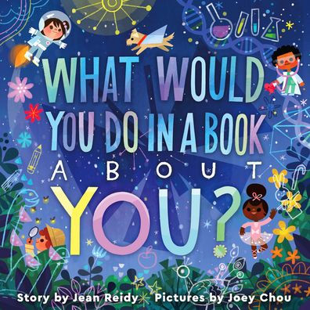
Can you imagine the picture book What Would You Do in a Book About You? by Jean Reidy and illustrated by Joey Chou (HarperCollins) being read by your entire class or community group? Whether the book is shared in a group read-aloud or as the performance text for a graduation ceremony, the text is empowering when read by many voices.

This Readers Theater script is laid out for 20 readers plus a single “Lead” role. If you have 20 readers, each reader will have 3 lines from the book to read aloud. Readers 1 and 2 get a few back and forth lines.
For a downloadable, editable Word Document of this script visit: http://bit.ly/WWYDGradKit

You are welcome to alter the roles in the document, but please do not alter the text. Out of respect for the book’s creators and their copyrights, please do not use this script as a replacement for the actual book in your classroom. As with all picture books, What Would You Do in a Book About You? is best experienced with Jean Reidy’s text and Joey Chou’s illustrations beautifully blended on the page. The book is available wherever books are sold and shared.
Script
Lead: Together, we will be reading the picture book What Would You Do in a Book About You? by Jean Reidy, illustrated by Joey Chou, and published by HarperCollins.
[Wait for the page to turn.]
1: HOOOOOOOO!
2: Who?
1: What about you?
2: Me?
1: You!
3: What would YOU do?
4: The story starts now.
5: Your tale is brand-new.
6: What would you do in a book about YOU?
[Wait for the page to turn.]

7: Would you venture above or below or beyond –
8: with help from a broomstick?
9: Or maybe a wand?
[Wait for the page to turn.]
10: Would you skip across stars or a planet or two?
11: Would you go it alone or invite a whole crew?
[Wait for the page to turn.]
12: Adventure is waiting.
13: So much you can do
14: in this wonderful, wander-filled book about you.
[Wait for the page to turn.]
15: Would you rescue a king or a queen or a dog?
16: Would you capture a castle?
17: Sip tea with a frog?
[Wait for the page to turn.]
18: Would you ride on a dinosaur?
19: Romp with emus?
20: Would you dance with a yak while you both play kazoos?
[Wait for the page to turn.]
1: Would you cure polar bears of the polar bear blues?
2: The polar bear blues?
1: The polar bear blues!
3: Well, then! Cure walruses too!
4: You don’t have to choose!
[Wait for the page to turn.]
5: You might create something that changes a mind –
6: or makes a heart stir.

7: You might simply be kind.
[Wait for the page to turn.]
8: You might give a big speech.
9: Or defend something small.
10: You might open a window.
11: Or tear down a wall.
[Wait for the page to turn.]
12: And when trouble comes, you might bravely stand tall.
13: You might muster your courage …
14: to rise from a fall.
[Wait for the page to turn.]
15: Would you march slow and steady?
16: Or sprint from the start?
17: Would you follow the crowd?
18: Or lead from your heart?
[Wait for the page to turn.]
19: The choices are endless.
20: The obstacles few.
1: So many chapters
2: beginning to brew.
3: Imagine the endless good you might do,
4: in a heart-warming,
5: heart-building
6: book about you.
[Wait for the page to turn.]
7: You might read a book!
8: You might write a book!

9: A powerful, page-turning, book about you!
All: A book about you in a book about you?
[Wait for the page to turn.]
10: Amazing!
11: Astonishing!
12: Astounding!
13: Absorbing!
14: Absolutely, undeniably, unmistakably …
15: awe-inspiring –
16: times two!!!
All: PHEW!
[Wait for the page to turn.]
17: If your life were a book with pictures and pages,
18: what would YOU do to be read through the ages?
19: Stop. Dream. Think it through.
[Wait for the page to turn.]
All: What would you do in a book about YOU?
20: The End … or, rather –
All: the Beginning!

